[](http://www.bing.com/images/search?q=images+of+math&view=detailv2&qpvt=images+of+math&id=09E83E1F49D96B5D5A7291EA5253F3D33619D755&selectedIndex=4&ccid=Wu4d6E48&simid=608051027722177128&thid=JN.AbNHGuSGghcF6IRnE0j0Jg)WELCOME 2019-2020 GEOMETRY LAB

HELENA HIGH SCHOOL

MRS. WALSH – ROOM 37

[vwalsh@helenaschools.org](mailto:vwalsh@helenaschools.org)

<https://hhs.helenaschools.org/teachers/vickie-walsh/>

406-324-2317

***2020-2021 MOTO:***

***“You want to fulfill the highest expression of yourself as a human being.”***

***Oprah Winfrey***

This course syllabus will be a course guide and is subject to change to accommodate the individual and/or class needs. Please review this syllabus with your parent. Thank you for your support as we look forward to a successful year. The syllabus will remain on my teacher web page for easy reference throughout the year.

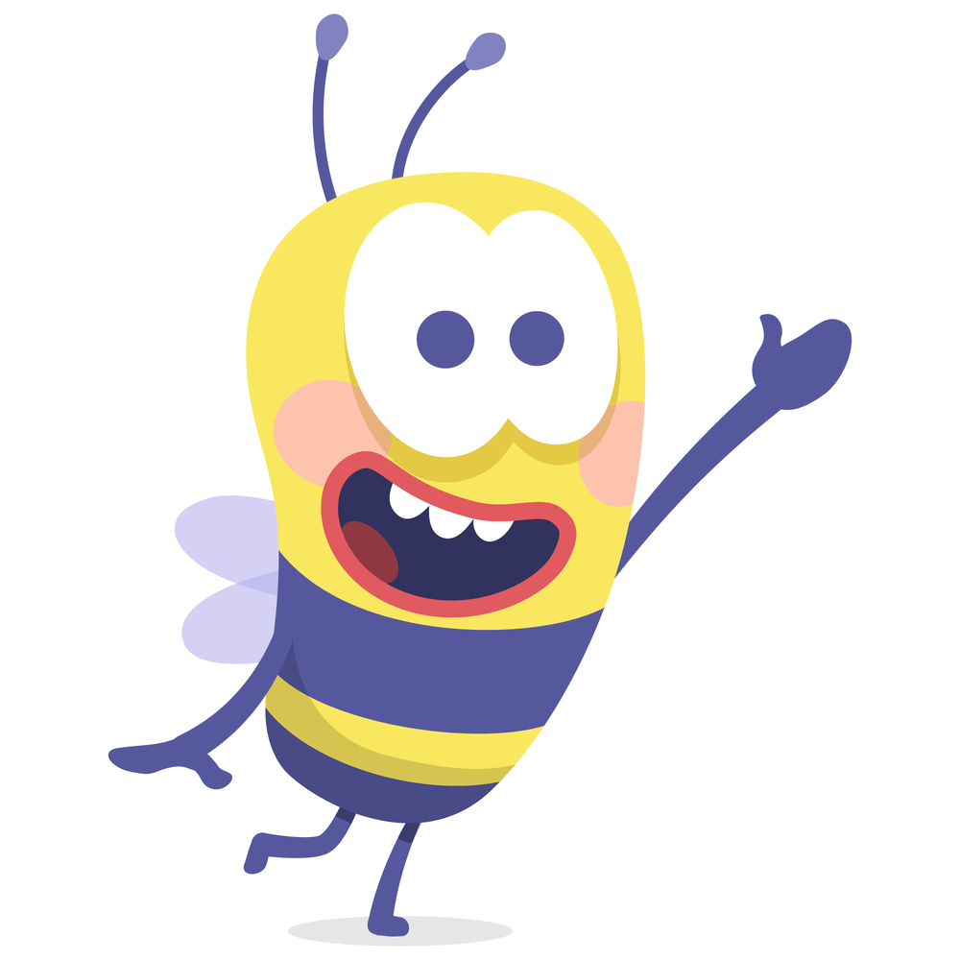

***Student Expectations:*** Please refer **Attachment A** for Helena School District Student Expectations for Blended and Digital Learners

***Geometry Lab Specific Goals*** - This class is for Geometry students who are willing to work hard, but just find themselves needing extra help in math. Time is spent in class working on homework/classwork for Geometry, practicing material being learned in that class, and at times even previewing upcoming topics. Due to the nature of the class and its smaller size, many students find that they are in a better position to get help in the lab class, and, often end the year with a higher level of math confidence. Students do earn an elective credit for being in the lab – an added bonus!

|  |  |
| --- | --- |
| Letter Grade | Percentage (%) |
| A | 91-100 |
| A- | 90-90.99 |
| B+ | 88-89.99 |
| B | 82-87.99 |
| B- | 80-81.99 |
| C+ | 78-79.99 |
| C | 72-77.99 |
| C- | 70-71.99 |
| D+ | 68-69.99 |
| D | 62-67.99 |
| D- | 60-61.99 |
| F | 0-59.99 |

***CLASSWORK/HOMEWORK EXPECTATIONS & GRADING***:

***GRADING PERCENTAGE***

The District grading scale will be followed as describe at the right:

***CLASSWORK/HOMEWORK PARTICIPATION***

Classwork is an important way to practice skills and help you remember what you are learning. The classwork make-up policy is the same as the HHS handbook.

***No homework will be given in Geometry Lab*.** The class is designed to make you successful in Geometry class. There will be opportunities in Lab to ask questions and work on homework from Geometry class (homework time is not always guaranteed). You will be expected to participate in class activities and classwork in Lab. You will be expected to complete activities in class and will often be graded on effort over accuracy – **Try Your BEST!**

***GRADING POLICY***

20% Regular Math Class completion/participation - homework/classwork submittal each quarter grade

80% Geometry Lab Participation and Completion of Activities

***PARTICIPATION***

Classwork will be graded based on participation on a 5-point scale.

**5/5 points** –prepared to work with appropriate materials, fully participate in class discussion and activity throughout the entire period, submit work at the end of the period.

**4/5 points** – tardy, without appropriate materials but request to borrow materials prior to class beginning, fully participate in class discussion and activity throughout most of the class period with only one redirect

**3/5 points** - tardy, without appropriate materials but request to borrow materials, participate in class discussion and activity throughout most of the class period with only one-two redirects

**2/5 points** - tardy, without appropriate materials, rarely participates in class discussion and activity throughout even with multiple requests during the class period

**0/5 points** – tardy/unexcused absence, and excused absence not made up, not prepared for class, refuses to participate in class discussion or activity, off task most of the period

***SEMESTER FINAL***

Attendance for the semester final for this class is **MANDATORY** and will take place during the final scheduled time for this course.

***CURRICULUM BIG PICTURE: SUGGESTED MATERIALS AND SUPPLIES***

**Semester 1** 2 Notebooks

Review Tools of Geometry Calculator

* Reasoning and Proof Pencils

* Parallel and Perpendicular Lines Eraser

* Congruent Triangles Compass

* Relationships in Triangles Ruler or Straight Edge

* Quadrilaterals

**Semester 2**

* Proportions and Similarity

* Right Triangles and Trigonometry

* Transformations and Symmetry

* Circles

* Area of Polygons and Circles

* Extending Surface Area and Volume

* Probability and Measurement

***CLASSROOM PROCEDURES/EXPECTATIONS:***

* **Be a graduate**
  1. Do your best on everything that you do.
  2. Ask for help when you need it
  3. Put your focus on learning math
  4. Elective credit is given for this class.
* **Be Responsible**

1. Be prepared daily (pencil, pen, notebook, textbook, and calculator).
2. Be here on time
3. Be in assigned seats when class starts and begin Bell Ringer work
4. Complete all classwork/Keep up on your notebook

* **Be Involved**

1. Be an active participant in class
2. Get involved in clubs and extra-curricular activities at HHS
3. You are responsible to get your make up work and assessments completed in a timely manner

* **Be respectful**

1. Be polite
2. Do not use electronic devices unless directed by me in this class.
3. Keep the classroom clean.
4. Be Positive

Attachment A

**6-12 STUDENT LEARNING EXPECTATIONS**

**For Students**

* A blended learning experience is not easier or harder than a traditional school day, it is just different.
* **As we enter the 2020-21 school year, the expectations for learning in a remote and blended environment have accelerated** since last spring.
* Be prepared to complete schoolwork 5 days a week regardless of whether we are at school or online.
* Homework and assignments will be posted to Teams and teacher webpages on Mondays. Start there each week. Manage your time daily with a planner or online calendar. Assignments will be posted weekly in PowerSchool.
* Check your school email and Teams daily and touch base with your teachers as often as possible.
* During a blended or remote learning environment, students will always act with academic integrity. Academic honesty is paramount to student learning in a blended environment that requires remote learning in addition to attending school in the building. Students are expected to act as they would in a traditional school setting and submit work that represents their authentic learning. Failure to do this will result in following school and district protocol for student plagiarism.

| Be Involved | Be Respectful | Be a Graduate | Be Responsible | Take Care of Yourself! |
| --- | --- | --- | --- | --- |
| * Join a club or activity. * Encourage your peers in their endeavors. * Participate in virtual school spirit activities. * Participate in all assigned Teams chats/discussions. * Volunteer in the community. (Reach out to our community through service learning.) * Help other students virtually when needed. * Develop and promote a positive mental attitude. * Take care of your social/emotional health – reach out to counselors and for resources when needed. | * Use school-appropriate and positive words in all communications (smile) through Teams. * Do not remove other students from a Teams call/meeting. * Use your school email and Teams for communication with your teachers and your peers. * Try not to read tone into communications from teachers/fellow learners. * Respect your teachers’ personal time in hours outside of school time. * Be honest with your teachers and parents/family when discussing work completion and grades. * Realize teachers have 24 hours to reply to emails and Teams chats during the school week. Try to use teacher office hours as much as possible. | * Remember the goal is that YOU LEARN! * School is 5 days a week. You will have activities each day for each class whether online or in-person. * Check Teams daily for each class. * Plan to do schoolwork each day. Realize that in-person school is six hours a day, so plan your online work accordingly. * Set aside a quiet time and space to work at home each day. * Carefully read and follow all communication from your teachers (weekly agendas, posts in Teams, assignment directions, etc.). * Engage in all online tasks provided by your teachers (watch videos, read text, complete assignments and tests, etc.). * Challenge yourself to do your best. Take pride and ownership of your education to prepare yourself for your future. | * Turn in assignments on time. * Seek help when needed. * Acknowledge teachers’ digital communications. * Check PowerSchool at least once a week. * Use a calendar or planner to organize your week. * Follow rules of academic integrity/honesty. Your work must be original; create authentic work. * Engage in each class daily (Monday-Friday). * Be an active learner. * When you have an online meeting with a teacher, join a few minutes early. Communicate with your teacher ahead of time if you cannot make the meeting. * Take care of your school-issued device. * Follow the school dress code when participating in live meetings and recording videos for class assignments; make sure your background is school appropriate. | *School Counselor Contacts:*  *Jaime Pandis (A-E)* [*jpandis@helenaschools.org*](mailto:jpandis@helenaschools.org)  *406 282-4178*  *Ellaina Staldine (F-L)* [*estaldine@helenaschools.org*](mailto:estaldine@helenaschools.org)  *406 640-3117*  *Jason Murgel (M-R)* [*jmurgel@helenaschools.org*](mailto:jmurgel@helenaschools.org)  *406 290-9449*  *Chrissy Murgel (S-Z)* [*cmurgel@helenaschools.org*](mailto:cmurgel@helenaschools.org)  *406 426-1272*  *Corena Hall, Office Manager* [*chall@helenaschools.org*](mailto:chall@helenaschools.org) |

# **Helpful Resources**

Not sure how-to login? Start here: <https://helenaschools.org/remote-learning/remote-learning-bridge/>

Need a guide for using Teams? Try this: <https://go.microsoft.com/fwlink/?linkid=2131456>

Can’t log in to Teams or Clever? Ask your teacher to email the help desk!

Parents need access to PowerSchool? Have them call your school office.

Trouble with your Chromebook? Try holding the power button down and re-starting. For more information, check here: <https://support.google.com/chromebook#topic=3399709>

