All of items can be purchased locally. American Welding and Gas and General Distributing give a student discount. Rock Hand, Power Townsend, Murdoch’s, Lowe’s and Home Depot. If you have any questions or cannot afford an item please contact Cindy Galbavy 324-2180 or cgalbavy@helenaschools.org
Welding Supplies for Welding Students
Gloves- they need to have welding gloves and look something like following picture. 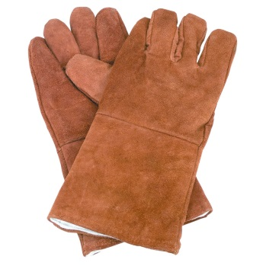
Safety Glasses- that are Z87 approved. The first pair is for a student that doesn’t wear glasses. The second pair is for students that wear glasses.
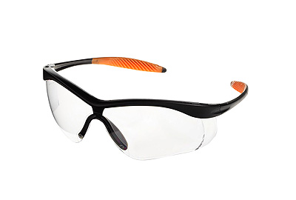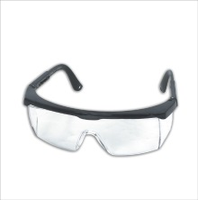This pair fits over glasses.
You can also purchase if you want but I provide welding goggles: Shade 5 glasses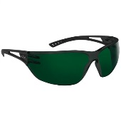
Pliers – They need one pair of following pliers. Please buy cheap pliers. 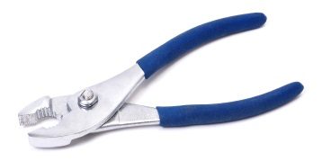
Boots – They need a pair of leather boots. You can purchase used ones at any thrift store. Here are examples of the boots.
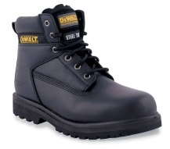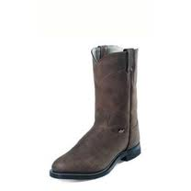

Coveralls or 100% cotton shirt and old pair of jeans. Jeans cannot have any frays on them.
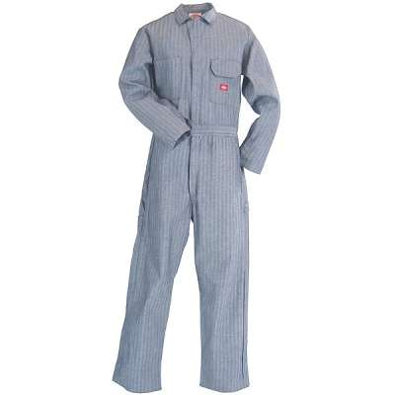These are about $45.00 or more at Murdoch’s. 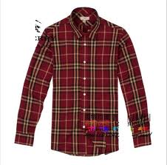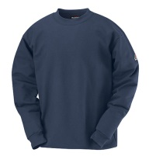old shirt or new 100% cotton shirt.
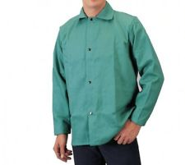This coat would also work and I believe they run around $30.00 at American Welding & Gas and General Distributing.
Measuring Tape 25’-
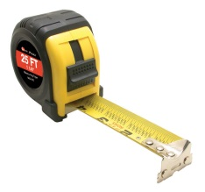
Hat – old hat that is cotton or you can buy welding cap.
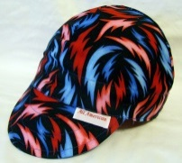

Welpers or MIG Pliers-
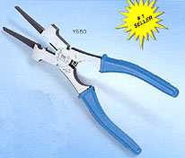
All of items can be purchased locally. American Welding and Gas and General Distributing give a student discount. Rock Hand, Power Townsend, Murdoch’s, Lowe’s and Home Depot. If you have any questions or cannot afford an item please contact Cindy Galbavy 324-2180 or cgalbavy@helenaschools.org

