Acids, Bases and pH Name Period
In the reading below highlight important terms and fill in notes as you read
Acids, Bases, and pH
Water molecules sometimes break apart to form ions. This reaction can be shown by a chemical equation. The double arrows show that the reaction can happen in either direction.
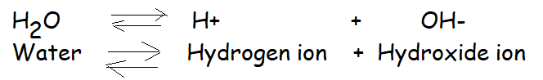

The pH scale: Chemists use a measure system called the pH scale to show the concentration of H+ ions in a solution (mixture in which the molecules of the mixed substances are evenly spread out). The pH ranges from 0 to 14. At pH 7, the concentration of H+ and OH- is equal. Pure water has a pH of 7. Solutions that have a pH below 7 are acidic and have more H+ ions than 0H-. The lower the pH, the higher the acidity. Thus, the smaller the number the higher the H+ ions and the lower the pH. Solutions that have a pH of 7 are basic. They have more OH- ions than H+ ions. The higher the pH is, the more basic or alkaline the solution is.
Acids: An acid is any compound that releases H+ ions in solution. Acidic solutions have a pH below 7. Strong acids tend to have pH values ranging from 1 to 3. The hydrochloric acid (HCL) made by the stomach to digest food is a strong acid with a pH of about 2.5.
Bases: A compound that releases hydroxide ions (OH-) in a solution is called a base. Basic solutions have pH values above 7. Strong bases, such as lye (NaOH) used in soapmaking tend to have pH values ranging from 11 to 14.
pH is a logarithmic scale that runs from 0 to 14. Each pH value below 7 (pH of pure water) is ten times more acidic than the higher value and each whole pH value above 7 is ten times less acidic than the one below it.
Question | Bullets | Notes/examples
What is the pH scale?
What is the range of pH and what is a neutral pH?
What type of solution has more H+ ions than OH- ions?
What type of solution has more OH- ions than H+ ions
What is an acid?
What is a base?

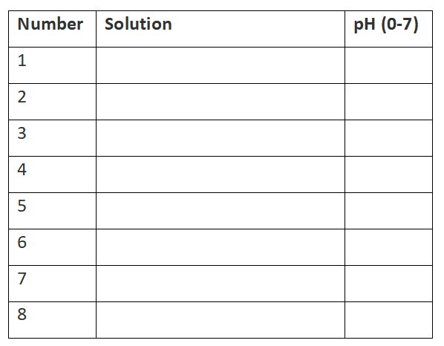
Directions
1. Put on safety googles and lab aprons.
2. Put approximately 1 mL (one dropper full) of each solution into test tubes 1-7. The toothpaste pH is completed (#8) so just record in your data table.
3. Add a pH strip to each test tube and record the pH in the datatable.
4. Use a ruler to draw a straight line to represent the pH scale. Label the left side 0 and the right side 14. Determine the center line, draw a mark and label 7 (neutral). Then, fill in each of the substances measured above in the approximate location.
Why pH matters in biological systems: Most human body system range from pH of 6.5 to 7.5, except for the stomach since stomach acid contains a pH of approximately 2.5. A pH lower than 6.5 or greater than 7.5 can be dangerous. Many chemical reactions in the body decrease or increase pH. When the pH changes various buffering systems in the body restore the cells to homeostasis, which is the process of maintaining a stable internal environment. Buffers are weak acids or bases that can react with strong acids or bases to stop sudden sharp changes in blood pH.
If Buffering Fails: Certain diseases can influence the pH balance and disrupt homeostasis. Alkalosis is a condition that occurs without enough carbon dioxide, and the pH levels become too high. This can result from liver disease and lung disease. Acidosis is a condition that occurs with too much carbon dioxide, or from other chemical reactions. In this condition the pH is too low. This condition can also result from damage to the lungs. Also, other conditions such as diabetes, diarrhea, kidney disease, and cancers can cause acidosis.
1. What is a buffer?

2. What is homeostasis?

3. What is acidosis and what are some causes?

4. What is alkalosis and what are some causes?

