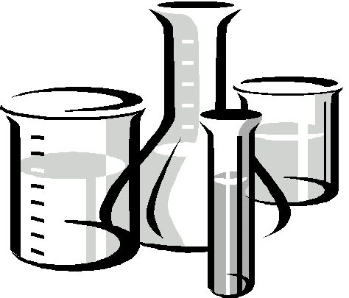Science Syllabus

|  |  |  |
| --- | --- | --- |
| Course Information: 8th Grade Physical Science | | |
| Mrs. Thomas | Mr. Muir | Mr. Lynn |
| [sthomas@helenaschools.org](mailto:sthomas@helenaschools.org) | [jmuir@helenaschools.org](mailto:jmuir@helenaschools.org) | [hlynn@helenaschools.org](mailto:hlynn@helenaschools.org) |

|  |
| --- |
| Supplies |
| Students will need the following supplies daily:   * **Charged** computer * Composition notebook designated for science * Science Starter (used daily) * Pencils, colored pencils/crayons * Ruler (6” or 12”) * Large glue stick   For in-person learning, students will **not** need to carry their supplies in a backpack – students will have access to a locker. |

|  |
| --- |
| Description |
| Eighth grade Physical Science is a full year, laboratory science class. Topics covered include many areas of chemical and physical science including the scientific method, forces and motion, matter, and energy. |

|  |
| --- |
| Classroom Expectations |
| 1. When you enter the classroom, a Science Starter will be projected. You should unpack and complete this first. You get ½ point for attempting to answer the question and ½ point for correcting it as the class goes over the answer. Use 2 different colors! |
| 2. Time between classes is 4 minutes. Students should move efficiently between classes and not linger at the lockers. |
| 3. Students will be expected to communicate online with Teams, Outlook and Clever. Assignments for each week will be posted in Teams. Students are responsible for checking assignments and checking grades on PowerSchool. |
| 4. Classwork- Students are expected to be engaged learners. Classwork is the practice needed to have academic success. Classwork will count for no more than 40% of your grade this year. |
| 5. Tests- Students will be allowed opportunities for retakes. This will not be the exact same test, so students should do some extra practice if a test score was low. Students will have one week to arrange for a retake, or the teacher may schedule this as well. |

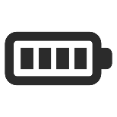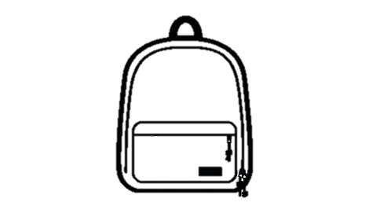

|  |
| --- |
| Technology Use & Academic Integrity |
| 1. A **CHARGED** computer is needed every day at school or at home. |
| 2. Cell phones are **not** needed and should not be seen during the school day. |
| 3. Students are expected to maintain academic honesty. As detailed in the handbook, there are consequences for plagiarism/copying. |

|  |
| --- |
| General Classroom Rules |
| 1. Hats are allowed in the classroom except on lab days. Hoodies are not allowed. |
| 2. Dismissal from science is after all supplies are returned and your lab area is clean. Students should keep work out until the teacher says they may pack up. |
| 3. Students will receive a safety contract in the first few weeks which will also need to be signed. |

|  |  |
| --- | --- |
| Syllabus Acknowledgement | |
| I acknowledge that I have read and understand the science syllabus for the 2022-2023 school year. | |
| Student Name: | Student Signature: |
| Parent Name: | Parent Signature: |

