…………………………………………………………………………………………
Course Description and Standards
This course advances mathematical proficiency and deepens cultural understanding, aligning with Montana’s dual commitment to academic standards and Indian Education for All.
According to Montana’s Mathematics standards, students engage with four major domains, while applying the Standards for Mathematical Practice.
- Expressions & Equations: Solve linear equations and systems of equations by manipulating expressions.
- Functions: Explore, graph, and interpret functions—identifying relationships between variables in these functions.
- Geometry: Analyze two- and three-dimensional figures; explore congruence, similarity, and various transformations (reflections, transversals, rotations, dilations)
- Statistics & Probability: Represent data with scatterplots, box plots, dot plots; model associations and variability, use the data to make data-based observations and conclusions.
Standards for Mathematical Practice prompt students to:
- Make sense of and persevere in problem-solving.
- Reason abstractly and quantitatively.
- Construct and critique mathematical arguments.
- Model with mathematics in real-world settings.
- Use tools strategically (e.g., graphs, technology).
- Communicate precisely, look for structure, and notice regularity in patterns.
Indian Education for All (IEFA)
Under Montana’s Constitution (Article X § 1(2)) and the law MCA 20-1-501, IEFA mandates that all students engage with the distinct cultural heritage of American Indians, and that educators incorporate these perspectives across Montana’s Essential Understandings guide this integration: recognizing tribal sovereignty, cultural diversity, oral traditions, and Indigenous worldviews.
In Math 8, we incorporate rich and engaging lessons for culturally grounded math experiences.
Examples of IEFA activities:
- Geometric Transformations through Montana American Indian Tribal Seals
- Beading Patterns Using Reflections
- Surface Area & Volume of Traditional Homes
These activities allow students to:
Explore reflection, rotation, and symmetry within Indigenous artistic themes.
Calculate surface areas and volumes of culturally significant structures like tipis or longhouses.
Engage meaningfully with tribal geometry, blending spatial reasoning with cultural artistry.
CONTACT INFO:
Nicholas Johnson
CRA – Room 118
406-324-2789
njohnson5@helenaschools.org
CR Anderson Middle School
Math 8 (Pre Algebra)

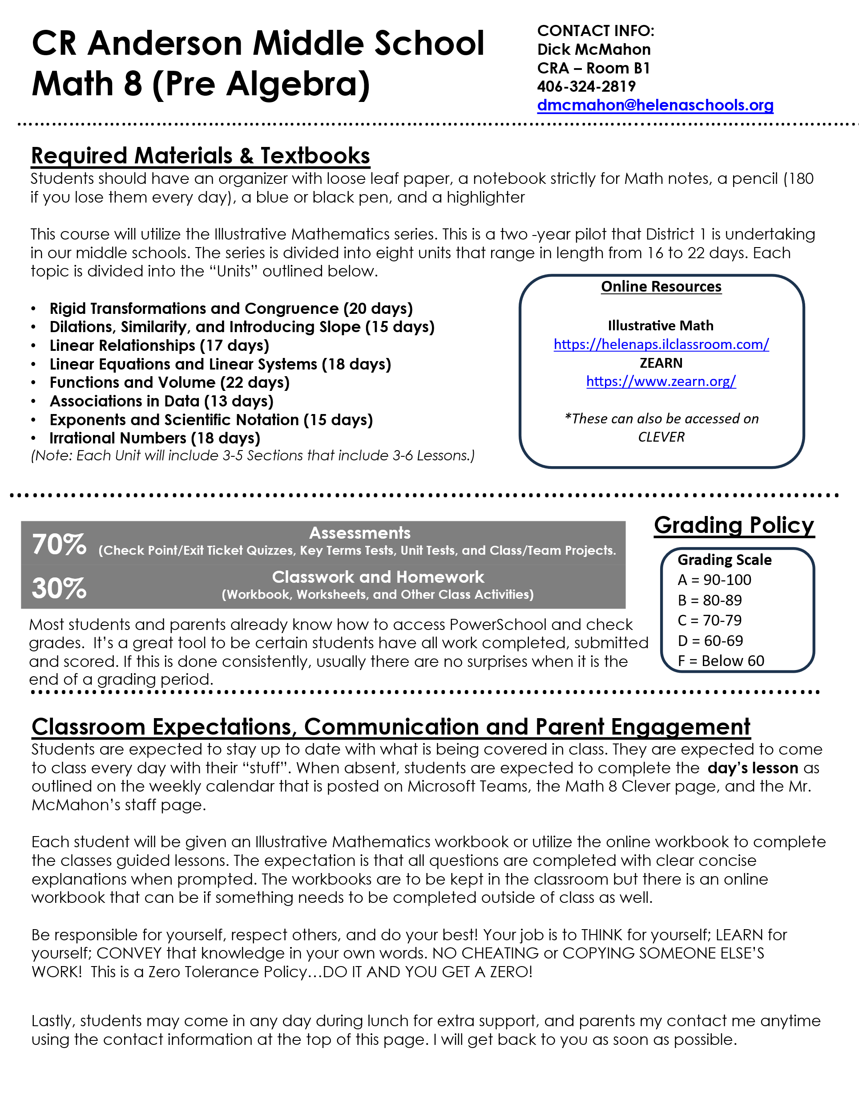
CONTACT INFO:
Nicholas Johnson
CRA – Room 118
406-324-2789
njohnson5@helenaschools.org

