HELENA HIGH SCHOOL
Piano Class Syllabus

Mrs. Molly Kohoutek
mkohoutek@helenaschools.org
406-324-2343
Course Description
Piano Class is designed for students with little to no piano experience who have a desire to develop basic piano playing skills. Time in class will be spent both on and off the keyboards and will consist of training in basic music theory and piano skills. Students will be working individually and as a class to master the techniques of playing and to explore a variety of literature. Piano Class provides a flexible learning environment which allows students to be self-paced in their practice and performance skills in order to meet course objectives. This course is offered as a semester course and fulfills .5 credits towards a Fine Arts or elective credit. This class can be taken many times and will be catered to each students playing level.
Expectations for Classroom Behavior
- Be prepared by bringing all necessary materials.
- Be present and on time.
- Participate in class activities.
- Follow directions. Play only when instructed to do so.
- Turn in written work on time.
- Plan ahead for absences.
- Treat all people with respect.
- Treat all pianos with care.
- Put your phone away during class.
- No food/drink on or near pianos.
- Practice, practice, practice!
- Communication with the teacher about personal concerns/questions should be done either before/after class or by appointment.
- Be flexible and open to constructive criticism. It is necessary for progress and music making to take place.
- Take responsibility for yourself, your actions, and your materials.
- Be kind to yourself as you are learning this new skill; mistakes are necessary and inevitable in the learning process.
- Be courteous to all, keep open-minded, be supportive, and have fun.

Objectives
Students will:
- Learn and apply all aspects of musical notation essential to playing piano
- Learn and apply basic music theory
- Develop their individual playing skills
- Demonstrate proper piano playing technique
- Work cooperatively in an ensemble
- Develop effective practice techniques
- Develop basic individual performance skills
Class Materials
- Sharpened pencil. No pens!
- Folder for extra materials
- Piano Adventures for Adults All-in-One Book

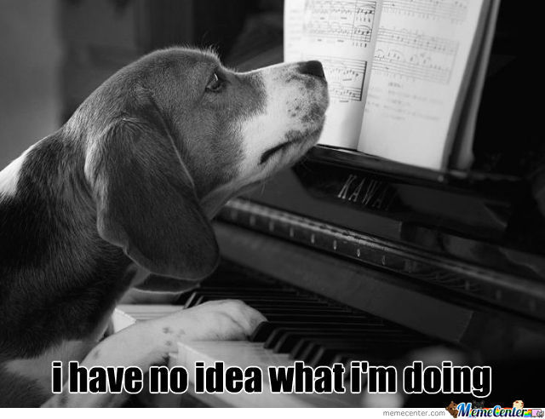
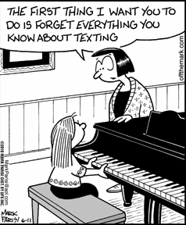
Classroom Protocols
Upon entering the classroom:
- Put your cell phone in your bag and set it aside
- Gather all materials for class (pencil, folder, book)
- Wash your hands in either one of the sinks at the back of the classroom
- Check the board for the Bell-Ringer
- Plug in your headphones and begin playing
At the end of the class period:
- Turn off your keyboard
- Put away all of your materials
- Push in your chair/bench

ALL ABSENCES (Excused, Unexcused, and School-Related):
- Students will have 2 days after the absence to complete a make-up assignment in order to receive their grade for that day. We will follow the procedures for make-up work outlined in the Helena High School Handbook (pg. 98-99)
- Students will be permitted a maximum of 10 absences during a semester with parental/guardian approval and/or medical documentation (school related not included).

Tardiness:
- We will follow the procedures for tardiness outlined in the Helena High School Handbook (pg. 99)
- If tardiness becomes an issue, a meeting with the student, parent/guardian, and administrator will be held
- If a teacher pass is given (green pass), tardy will be excused.

If there are any issues that are hindering your ability to come to school, please keep me informed. I want nothing more than to see each student succeed and I want to be able to help in any way I can. This will allow me to make a plan with you and be flexible as needed.

Absence Policies and Procedures
Individual success is reliant on repetition, consistency, and effort. This means that each student needs to be an active participant during class and is expected to utilize class time for deliberate practice. Students must also be willing to take risks and receive critiques while also demonstrating a supportive and positive attitude. Most importantly, this class requires that students are in attendance and establish proper attendance habits. Good attendance is essential to individual growth and is imperative to the progress we make on our instruments in class. As a result, the following policies and procedures on absences will apply:
Note: All policies and procedures reflect those outlined in the Helena High School Student/Parent Handbook and have been modified to fit the needs of this class.

Daily/Weekly Grading (20 points per week)
Daily points will be earned as follows: (see “Participation” above for a more detailed description)
- 4 points—Prompt, respectful, work hard, positive, on task, follows directions, full participation, no cell phone
- 3 points—Ready, mostly respectful, good effort, basically positive, some lack of attention/participation, cell phone violation
- 2 points—Not ready, disrespectful, somewhat off task/distracting, lack of effort and participation, cell phone violation
- 1 point—Not ready, disrespectful, off task, distracting, little to no effort, lack of participation, cell phone violation
- 0 points—Unexcused absence, referral to office, refusal for participation, make-up work not turned in

Inappropriate language will not be tolerated. If it becomes an issue, your administrator will be notified.

Grading Policy
Classroom Performance (70%)
Formal Assessment of Content and Performance (30%)

Classroom Performance (70%)
Participation (daily/weekly grade) see below
- Demonstrates appropriate technique and posture, engaged, responding to teacher’s instructions, attention towards person talking, not distracting others, arriving on time and ready to work, cell phone put away, plays piano only when instructed to do so, uses time appropriately to practice skills and complete written work, positive and supportive audience member when others are playing, employs musical concepts and skills (as discussed or written in music), asks questions when further help is needed
Content
- Piano technique, pitch and rhythm comprehension and notation, music theory concepts, scales, chords, dynamic and tempo markings, music vocabulary and corresponding symbols, articulations, individual and ensemble playing, composition and improvisation, piano performance literature, practice techniques, pedaling, performance style as appropriate for the literature, historical context of literature, written assignments and worksheets, written responses to literature and text, check ins

Formal Assessment of Content and Performance (30%)
- Written exams
- Playing checkpoints
- In-class recitals

